实验一：YOLOv8s 基线复现实验设计

Experiment 1: YOLOv8s Baseline Reproduction Design

1. 实验目的 / Objective
建立一个可复现的 YOLOv8s 胸部 X 光多病种目标检测基线，用于：
- 在 VinDr-CXR 完整 14 类病种检测任务上获得可靠的基础性能；
- 观察模型在完整 300 轮训练过程中的收敛、平台期与潜在过拟合；
- 为后续 RefConv、ECLA、Small-lesion Head 和 SFF 等模块消融实验提供唯一、可比较的参照模型。
To establish a reproducible YOLOv8s baseline for multi-disease chest X-ray object detection on the full 14-class VinDr-CXR task, and to provide a controlled reference for subsequent ablation experiments.

数据集与预处理 / Dataset and Preprocessing
- 数据集：VinDr-CXR（公开胸部 X 光数据集）
- 总规模：18,000 张胸片
- 划分：15,000 张训练图像，3,000 张测试图像
其中13500张用于训练，1500张用于验证，3000张官方测试集用于测试
- 任务覆盖 14 类异常：主动脉增大、肺不张、钙化、心脏增大、实变、间质性肺病、浸润、肺部阴影、结节/肿块、胸腔积液、胸膜增厚、气胸、肺纤维化及其他病灶
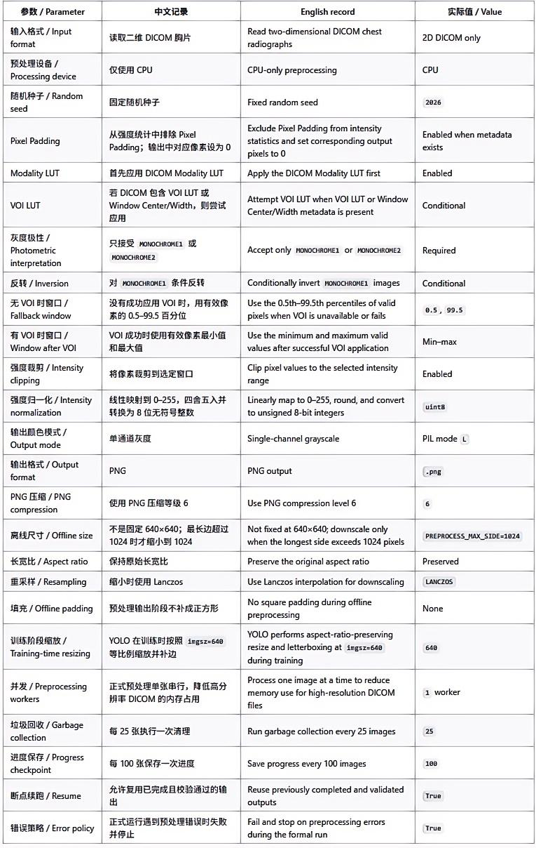

3. 基线模型与训练配置 / Baseline Model and Training Configuration
基线模型为 COCO 预训练的 YOLOv8s。训练配置如下：
- 输入尺寸：640
- Batch size：16
- 最大训练轮数：300
- Optimizer：SGD
- 初始学习率：0.01
- Momentum：0.937
- Weight decay：0.0005
- Warm-up：前 3 个 epoch
- AMP：启用
- 随机种子：2026
- Deterministic training：启用
- Early stopping：关闭
- 每轮验证：启用
- 每轮 checkpoint：保存
The baseline is a COCO-pretrained YOLOv8s model. Training uses input size 640, batch size 16, 300 epochs, SGD optimization, initial learning rate 0.01, momentum 0.937, weight decay 0.0005, three warm-up epochs, AMP, fixed seed 2026, deterministic training, disabled early stopping, validation at every epoch, and one checkpoint saved per epoch.
4. 训练与模型选择策略 / Training and Checkpoint Selection

训练固定执行完整 300 轮，不因短期平台期提前停止。每一轮均在 1,500 张内部验证集上计算损失、Precision、Recall、mAP50 和 mAP50-95。

候选 checkpoint 只能依据内部验证集选择。主选择指标为 mAP50-95，mAP50 和后期曲线稳定性作为辅助依据。官方 3,000 张测试集不用于从多个候选模型中挑选最佳模型。

Training is forced to run for all 300 epochs without early stopping. At every epoch, loss, Precision, Recall, mAP50, and mAP50-95 are calculated on the 1,500-image internal validation set.

Candidate checkpoints must be selected using the internal validation set only. The primary selection metric is mAP50-95, with mAP50 and late-stage curve stability used as secondary evidence. The official 3,000-image test set must not be used to choose the best checkpoint.

5. 最终评估 / Final Evaluation

在内部验证集确定最终 checkpoint 后，仅使用该模型在官方 3,000 张测试集上进行最终性能评估。报告指标包括 Precision、Recall、mAP50、mAP50-95、PR curve、F1-confidence curve 及典型预测案例。

After the final checkpoint is determined using the internal validation set, it will be evaluated once on the official 3,000-image test set. Reported metrics include Precision, Recall, mAP50, mAP50-95, PR curves, F1-confidence curves, and representative prediction cases.

6. 可复现性与记录 / Reproducibility and Record Keeping

保存内容包括：

results.csv：300 个 epoch 的逐轮训练与验证指标；
epoch1.pt 至 epoch300.pt：逐轮模型 checkpoint；
best.pt 和 last.pt；
数据划分文件、YAML 配置、训练脚本、随机种子及环境版本；
GitHub 中的代码、配置与实验记录。

Saved artefacts include the per-epoch results.csv, checkpoints from epoch1.pt to epoch300.pt, best.pt, last.pt, split files, YAML configuration, training scripts, seed and environment information, together with code, configuration, and experiment records archived on GitHub.

7. 后续消融实验控制原则 / Control Principle for Later Ablations

后续实验只改变一个待验证模块，例如 RefConv、ECLA、Small-lesion Head 或 SFF。数据划分、预训练权重来源、输入尺寸、batch size、训练轮数、优化器、随机种子、验证集选择规则和官方测试流程均保持不变。

Each subsequent ablation changes only one target module, such as RefConv, ECLA, the Small-lesion Head, or SFF. The data split, pretrained initialization, input size, batch size, epoch count, optimizer, random seed, validation-based checkpoint selection rule, and official test procedure remain unchanged.

